PORTFOLIO
sASSIGNMENT OF CSE111 (ORIENTATION TO COMPUTING-1)
COMPUTER SCIENCE AND ENGINEERING

Submitted by:
Name: SREELAKSHMI ES
Registration number:12416150
Roll No.: 58
Section: K24PR

Submitted to: Dr. PUSHPENDER


LOVELY PROFESSIONAL UNIVERSITY
DECLARATION
I, SREELAKSHMI E S , a student of Bachelor of Technology under CSE discipline at Lovely Professional University, Punjab, hereby declare that all the information furnished in this project report is based on my own work and is genuine

RegistrationNumber:12416150
Platforms for profile creation | Link to student profile | Screenshot
Figma | Since internal profile doesn’t work, so I am attaching project link  Project1: https://www.figma.com/file/LsX6JHrpwYpNdJsEeLzEjw/logo- 1?node-id=0%3A1&t=wzsAkkvr0BAZZQLC-1 | 1
Quora | https://www.quora.com/profile/Sreelakshmi-280 | 2
Stack overflow | mailto:https://stackoverflow.com/users/28380105/sreelakshmi-es | 3
Github | mailto:https://github.com/Sreelakshmi26-spec | 4
LinkedIn | mailto:https://www.linkedin.com/in/sreelakshmi-es- | 5-6
CV | https://docs.google.com/document/d/1Sz7plEAZMLnLDs8kGD TuEyq3WqEWgBTH/edit | 7
Technical mooc  registration Link and screenshot | https://www.mygreatlearning.com/academy/learn-for- free/courses/python-fundamentals-for-beginners | 8

FIGMA
Profile:
Figma internal profile with project
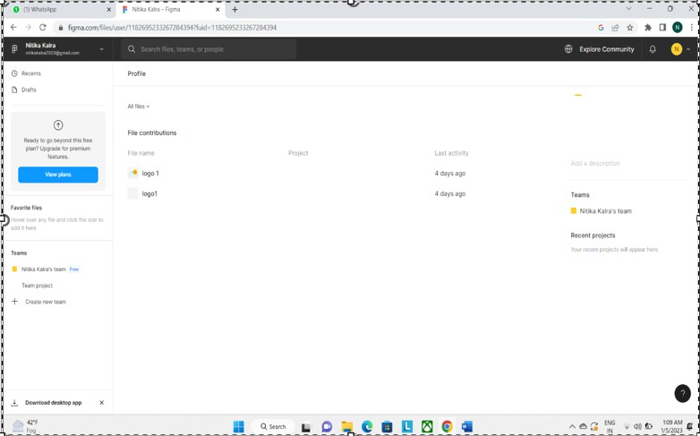
Accomplishment:


QUORA 2
PROFILE AND ACCOMPLISHMENT:

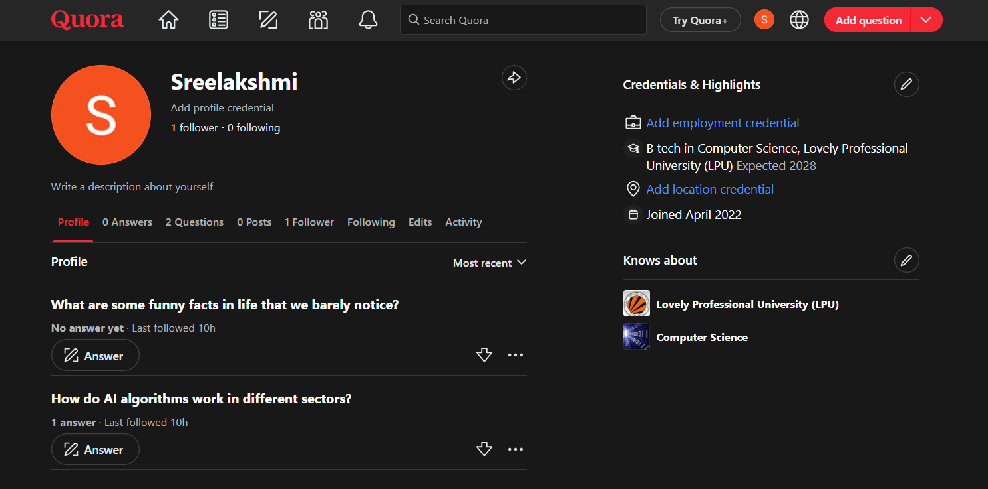

STACKOVERFLOW 3
PROFILE:
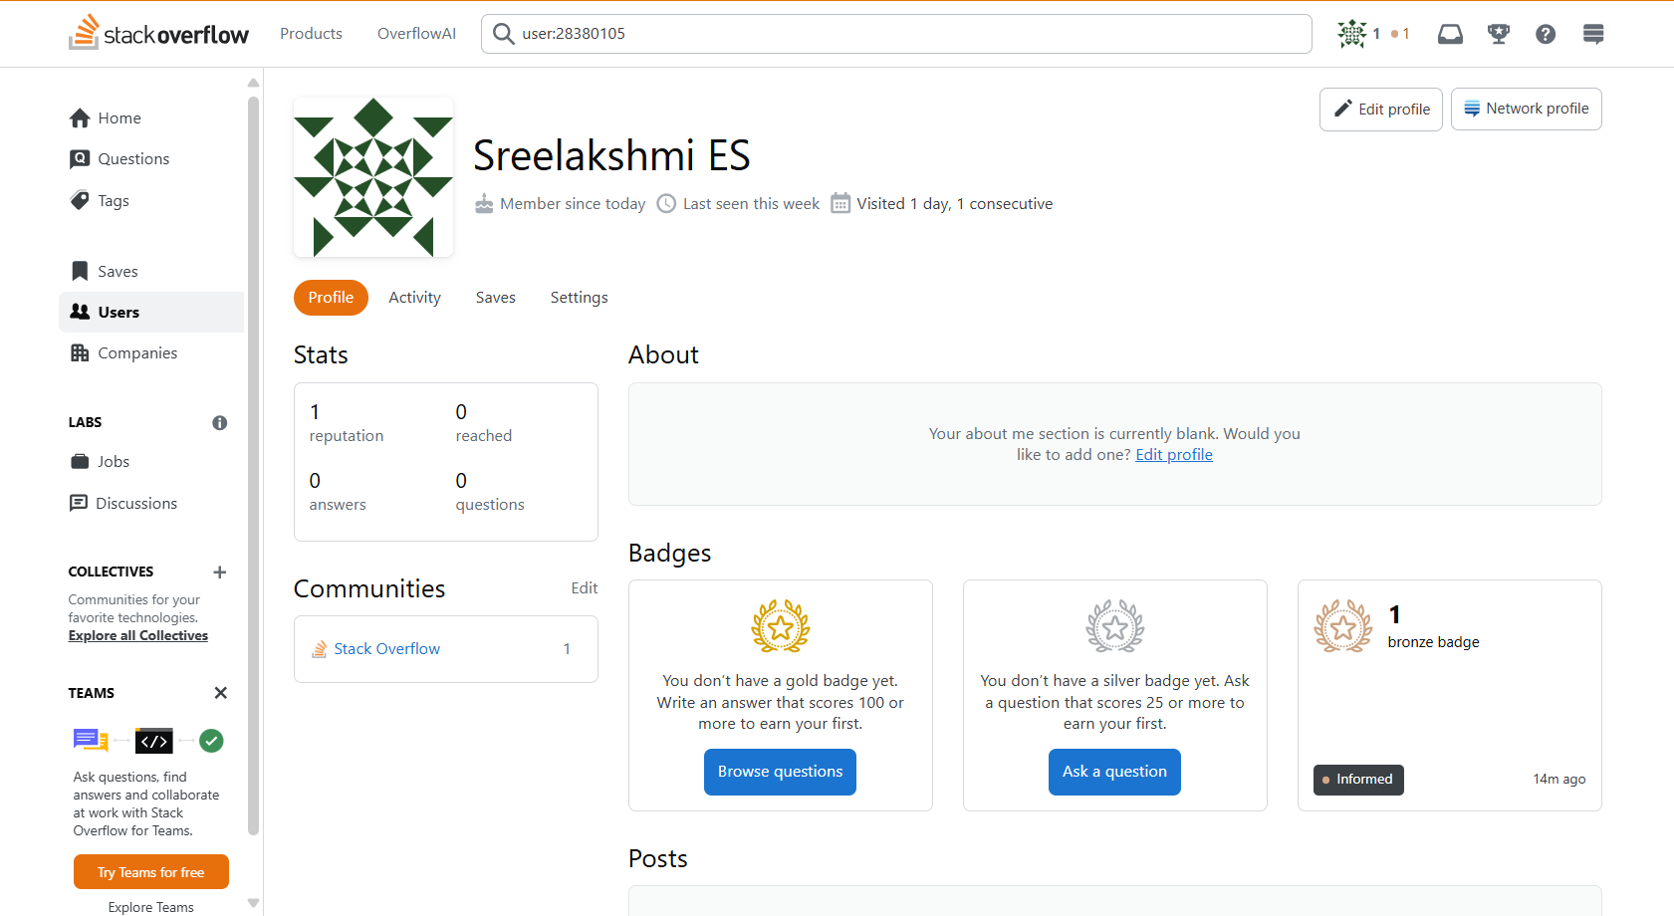
Accomplishment: Got a badge in STACKOVERFLOW
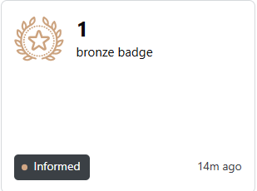

GITHUB 4
Profile:
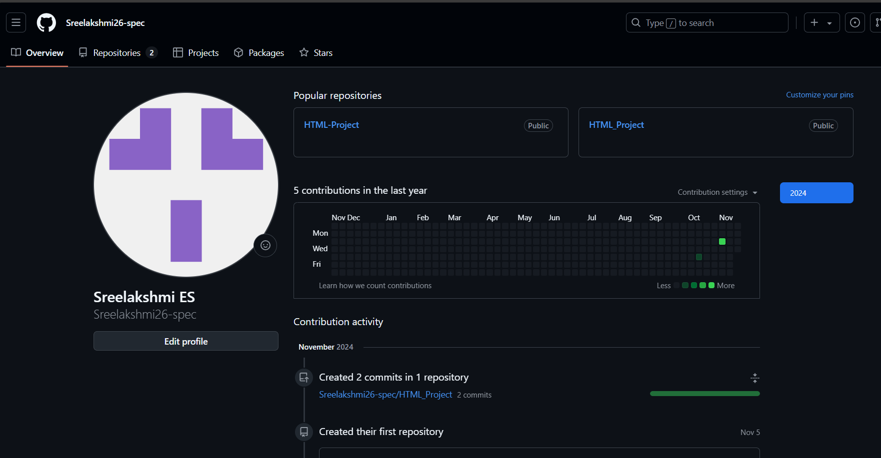
Accomplishment:
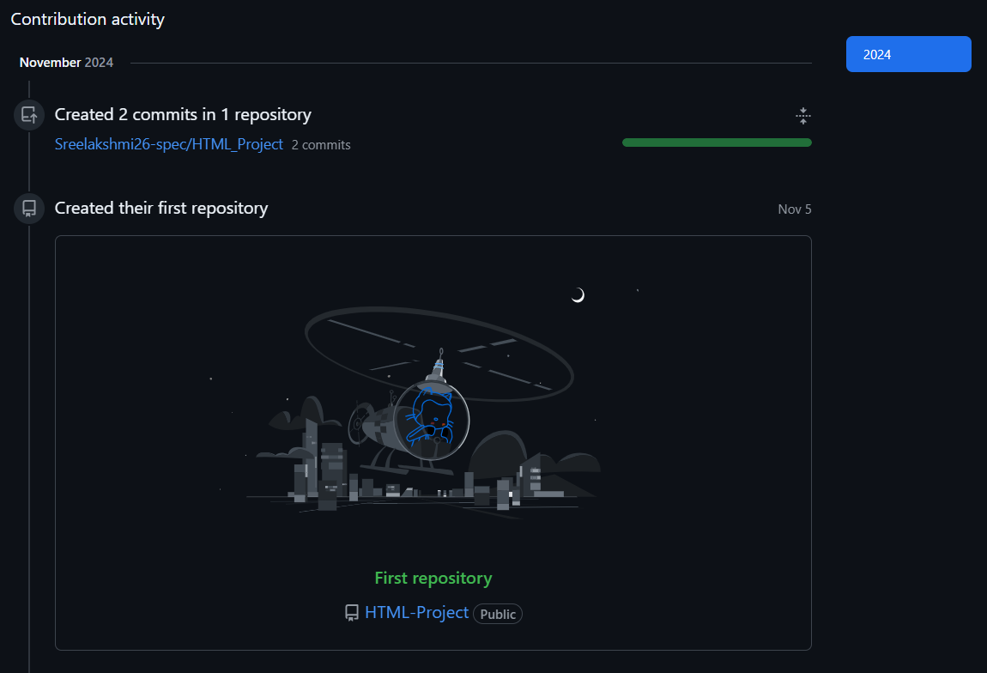

LINKEDIN 5

Profile: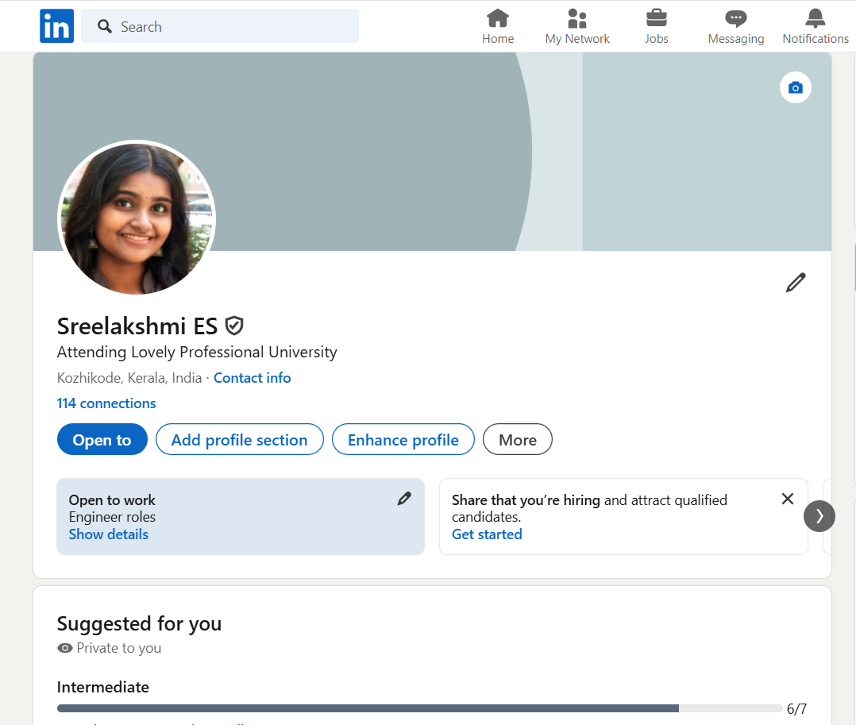

Accomplishment: 6
Uploaded My First Post On LinkedIn
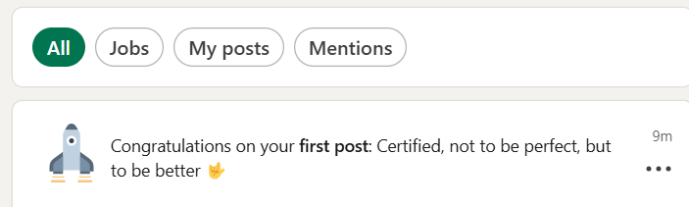

CV 7
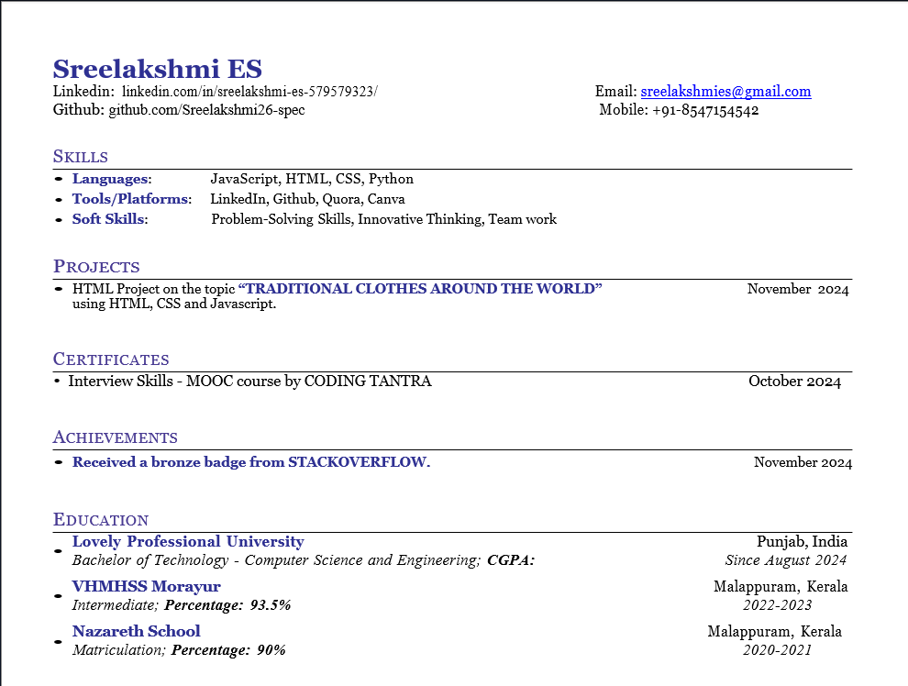
8

Technical MOOCS registration Link:-
https://skillera.org/ExploreCoursesPy

SCREENSHOT:-

